Title of my PR’19 contribution
Jane Doe,1 Claire Monnom,2 Peter Name3
1Department of Physics, University of Wherever,
Science Street, Wherever, ST 12345, USA
2Laboratoire de Physique, Rue de la Découverte, 57999 Labas, France
3Institut für Photonik, Lichtstrasse 42, 98765 Photonenburg, Germany

Introduction
This document is a template for the summary submission to the conference PR’19 using MS Word. You should not modify the document settings (margins, headers, etc.), the present submission must not exceed the length of two pages. The final file for the submission should be in Portable Document Format (PDF) and should be sent via the conference website at the address https://pr19.event.univ-lorraine.fr after login into your SciencesConf account.

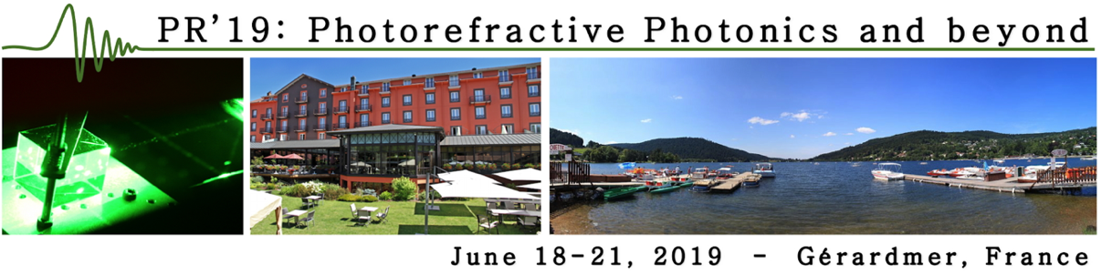
Figure 1: Caption describing my figure.
The font for the whole file should be Latin Modern Roman (LM Roman). If your system does not yet contain this font, you should first include it by double clicking on the files lmroman12-regular.otf, lmroman12-bold.otf and lmroman12-italic.otf, followed by a restart of your computer. The title should be in the font LM Roman Bold 16 points, authors list in LM Roman Regular 12 points, affiliations and main text in LM Roman Regular 11 points, eventual Section titles in LM Roman Bold 14 points, Figure captions and references in LM Roman Regular 10 points. Line spacing should be exactly 14 points. Paragraphs should be indented by 0.5 cm.
The summary may contain figures, equations and references provided that the total two pages length is not exceeded. References may be cited and included directly in the way shown here [1, 2]. Equations may be inserted inline or like this
$∆n=-\frac{1}{2}n_{0}^{3}r_{eff}E_{sc}$ (1)

Conclusions
The deadline for submitting the summary is April 30th, 2019. Please name your file in the following way, PR19-Six digit paper number-First author name, for instance PR19-252423-Doe.pdf
In alternative to the present Word template you may prepare your summary also with LaTeX using the corresponding template.

References
[1] P. Name and C. Monnom, Phys. Rev. Lett. 58, 12059 (2019)
[2] C. Monnom and P. Name, Nature 45, 1443 (2018)
[3] C. Monnom and P. Name, Science 5, 146 (2016)

